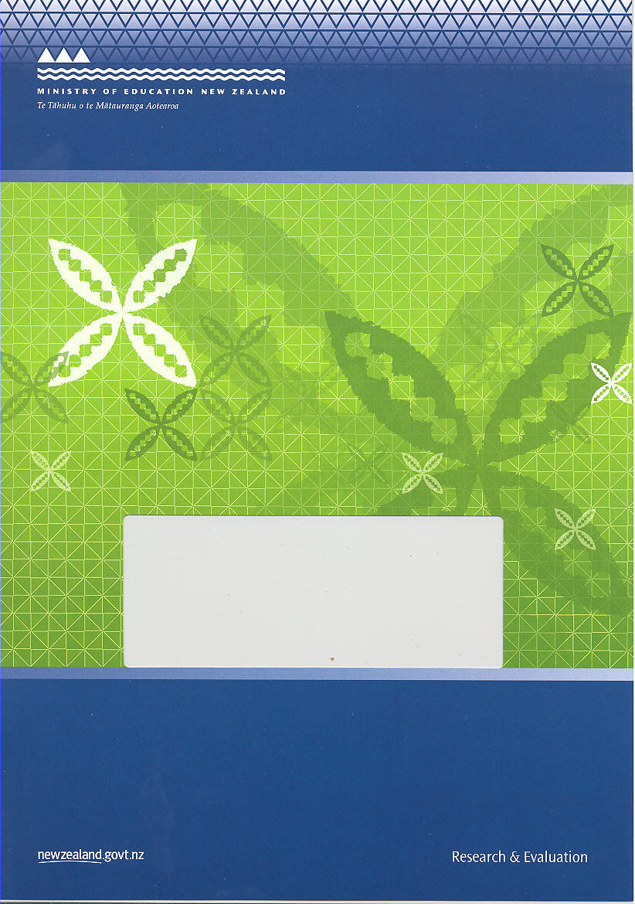
National Standards: School Sample Monitoring & Evaluation Project, 2010
Survey of Parents and Whānau, March 2011

Report to the Ministry of Education

Thomas, G., and Ward, J.
NZ Maths Technology Ltd

ISBN: 978-0-478-38606-6
ISBN: 978-0-478-38607-3 (web)
RMR-985

© Ministry of Education, New Zealand 2011
Research reports are available on the Ministry of Education’s website Education Counts:
www.educationcounts.govt.nz/publications.
Opinions expressed in this report are those of the authors and do not necessarily coincide with those of the Ministry of Education.

National Standards:
School Sample Monitoring and Evaluation Project, 2010

Survey of Parents and Whānau, March 2011

Gill Thomas and Jenny Ward


Dunedin

Contents
1. Methodology 5
Method 5
Response rate 6
Sample 6
2. Report content 8
3. Parents’ understandings and opinions 10
4. Summary 12
Appendix: Parent survey 13

List of tables
Table 1: Sample by year level and ethnicity 6
Table 2: Sample by year level and school decile 7
Table 3: Achievement information contained in reports 8
Table 4: Other information about reading, writing and mathematics contained in reports 9
Table 5: Usefulness of reading, writing and mathematics information 10

1. Methodology
This report describes results from a survey of parents and whānau. The perspectives of these respondents are positioned within the methodological framework of the National Standards: School Sample Monitoring and Evaluation Project, 2010.
Analysis is focused around the relevant monitoring and evaluation question from the larger study:
- How do schools use information from National Standards to report to and communicate with parents and whānau?
In particular, the survey was designed to collect information about the extent to which parents and whānau understand the information in their child’s report about their achievement in relation to National Standards and the ways in which families can support learning at home. Consistent with this aim, the views described in this report represent the ways in which parents and whānau have interpreted end-of-year reports rather than an objective analysis of report content. Differences between these perspectives and the findings of a direct analysis of reports are identified.

Method
The results in this report were obtained from a paper-based survey carried out in March 2011. The survey was a repeat of an online version that was administered in November 2010 for which the response rate was too low to provide useful information. In order to maximise returns, schools managed the distribution of surveys to the parents and whānau of targeted students and collected responses for their return. Surveys were distributed to the three students in each year level whose birthdays were closest to 1 January. Surveys for the targeted students who had left the school at the end of 2009 were posted to the family’s home if the address was available. For example, in schools catering for students in years 1 to 6, surveys were posted to the 2009 year 6 students. In six schools where there were less than three students in each year level, one survey was distributed to each family in the school.
In order to ensure the sample adequately represented the views of Māori and Pasifika families, six schools were over-sampled. In these schools one class of students at each year level received survey forms for their families to complete. Of these six schools, three had high proportions of Māori students (ranging from 75% to 100%), and three had high proportions of Pasifika students (ranging from 70% to 78%). All of these schools had a roll of at least 100 students.
Surveys were distributed to schools, in late February, following their agreement to participate. Schools then distributed these to families with a request for their return as soon as possible. Each survey had an envelope that parents and whānau could use to seal their responses in for return to the school. Schools were provided with a courier bag in which to return all completed surveys. The parents and whānau of students who had left the school the previous year posted their surveys directly using freepost envelopes provided.

Response rate
All 104 schools in the monitoring sample were emailed an invitation to assist with the distribution and return of surveys. Of these, 57 schools agreed to assist, and of these again, 50 schools returned completed surveys, a response rate of 88% by school. A total of 624 completed surveys were returned, representing 38% of the estimated 1660 surveys distributed to parents and whānau by participating schools.

Sample
Initial analysis of the sample showed it was significantly over-representative of Pasifika students (19% compared with 10% nationally), and students from low decile schools (45% compared with 24% nationally). The approach adopted to ensure the sample was representative was to randomly remove students from these over-represented groups in order to establish a representative sample. A total of 165 students were removed at random. Initially 65 low-decile Pasifika students were removed, and then an additional 100 students from all ethnicities at low-decile schools were removed. The resulting sample consists of 459 students, and is representative of the national population with no difference greater than 6% between represented groups and groups nationally. Tables 1 and 2 provide information on the demographic characteristics of the sample with national data for comparison.
Table 1: Sample by year level and ethnicity
Year level | Student ethnicity*
Year level | National* / % |  |  |  |  | Sample / %
Year level | NZE | Māori | Pasifika | Asian | Other | NZE | Māori | Pasifika | Asian | Other
Year 1 | 6.5 | 3.0 | 1.2 | 1.1 | 0.3 | 8.1 | 3.2 | 2.1 | 0.4 | 0.8
Year 2 | 6.6 | 2.9 | 1.3 | 1.1 | 0.3 | 6.9 | 2.8 | 0.8 | 0.6 | 0.2
Year 3 | 6.5 | 2.9 | 1.3 | 1.1 | 0.3 | 9.4 | 3.4 | 2.3 | 1.1 | 0.4
Year 4 | 6.6 | 2.8 | 1.3 | 1.0 | 0.3 | 8.3 | 3.0 | 0.6 | 0.8 | 0.2
Year 5 | 6.7 | 2.9 | 1.3 | 1.1 | 0.3 | 10.5 | 3.4 | 1.5 | 0.4 | 0.8
Year 6 | 6.9 | 2.9 | 1.2 | 1.1 | 0.3 | 7.5 | 1.1 | 0.6 | 0.9 | 0.4
Year 7 | 8.0 | 3.2 | 1.4 | 1.3 | 0.4 | 5.8 | 3.8 | 2.1 | 0.0 | 0.6
Year 8 | 7.0 | 2.9 | 1.2 | 1.2 | 0.3 | 2.8 | 0.8 | 0.2 | 0.0 | 0.2
Unspecified | - | - | - | - | - | 0.6 | 0.9 | 0.2 | 0.0 | 0.2
All years (%) | 54.8 | 23.6 | 10.2 | 9.0 | 2.4 | 59.8 | 22.3 | 10.1 | 4.1 | 3.6
All years (n) | 260,351 | 112,274 | 48,243 | 42,921 | 11,326 | 319 | 119 | 54 | 22 | 19
*Where students identified with more than one ethnicity, their information was included for all of the ethnicities specified.
Table 2: Sample by year level and school decile
Year level | School decile
Year level | National / % |  |  | Sample / %
Year level | Decile 1–3 | Decile 4–7 | Decile 8–10 | Decile 1–3 | Decile 4–7 | Decile 8–10
Year 1 | 3.0 | 5.1 | 4.0 | 4.6 | 4.4 | 4.8
Year 2 | 3.0 | 5.1 | 4.1 | 3.9 | 3.3 | 4.4
Year 3 | 3.0 | 5.0 | 4.0 | 4.6 | 5.4 | 6.8
Year 4 | 2.9 | 5.0 | 3.9 | 3.1 | 4.8 | 4.6
Year 5 | 3.0 | 5.1 | 4.1 | 3.9 | 6.3 | 6.1
Year 6 | 3.1 | 5.1 | 4.2 | 2.0 | 5.0 | 4.4
Year 7 | 3.0 | 6.7 | 4.9 | 4.6 | 5.2 | 2.2
Year 8 | 2.5 | 6.1 | 4.2 | 0.9 | 2.0 | 1.1
Unspecified | - | - | - | 0.4 | 0.7 | 0.9
All years (%) | 23.5 | 43.1 | 33.3 | 27.9 | 37.0 | 35.1
All years (n) | 103,032 | 188,889 | 145,864 | 128 | 170 | 161

In terms of gender the sample consists of 47% male and 53% female students. Nationally at years 1 to 8 there are 51% male and 49% female students.

2. Report content
Ninety-three percent of respondents indicated that their child's end-of-2010 report contained information about their achievement relative to the National Standards, while 7% indicated that it did not. These figures are substantially different to those obtained from a direct analysis of reports that suggested 79% of reports included information about students’ achievement against the standards. Although it is not possible to identify with any certainty the reasons for these differences, they may be an effect of a non-response bias in the sample. That is, it may be the case that schools that did not report against National Standards were less likely to agree to participate in the parent survey.
It is the responses of the parents and whānau who received National Standards achievement reports (93%, 425 responses) that are the focus of the remainder of this report. The responses of parents and whānau whose child’s end-of-year report did not contain National Standards achievement information were not analysed, as they contained no information about families’ understanding and perceptions of these reports.
Table 3 summarises respondents’ interpretations of the reading, writing, and mathematics achievement information in the reports they received.
Table 3: Achievement information contained in reports
Information | Reading | Writing | Mathematics
My child was above the NS for their year level | 45% | 22% | 28%
My child was at the NS for their year level | 38% | 54% | 51%
My child was below the NS for their year level | 14% | 19% | 16%
My child was well below the NS for their year level | 2% | 3% | 2%
There was no information in the report | 0% | 1% | 1%
I didn’t understand the information in the report | 0% | 1% | 2%

Most parents and whānau indicated that the achievement information in the reports they received described their child as at or above the National Standard for their year level. In reading, 83% of parents and whānau noted their child was rated at or above the standards, while in writing and mathematics these percentages were 76% and 79% respectively. Approximately 20% of parents and whānau noted that their child was described as below or well below the standards in all three areas. Very small proportions of respondents indicated either that the report they received did not contain achievement information in a particular area, or that they didn’t understand the information in the report.
Within the sample there were substantially smaller proportions of students rated below or well below the standards than nationally. National results suggest that, on average 28% of students were below or well below the reading standards, with 37% and 35% respectively below the writing and mathematics standards. It is not possible to identify the reasons for these differences, but they may be attributable to a non-response bias, with parents of students rated at or above the standards more likely to respond to the survey.
Parents and whānau responses indicated that in addition to achievement information, reports contained a range of other reading, writing, and mathematics information. Table 4 lists these elements and the proportions of respondents identifying them as present in reports.
Table 4: Other information about reading, writing and mathematics contained in reports
Information about reading, writing, and mathematics | Proportion of reports
Progress made in by child in 2010 | 92%
Child’s learning goals | 90%
Ideas for how to support child’s learning | 86%

Table 4 shows that the majority of parents and whānau (92%) identified their child’s end-of-year report as containing progress information in reading, writing and mathematics. Most parents and whānau (90%) also indicated that information about their child’s learning goals in these areas were provided. Slightly smaller proportions of parents and whānau noted that reports contained ideas on how they could support their child’s learning (86%).
These proportions are different to those obtained from an objective analysis of end-of-year reports which suggested that 70% of reports included students’ learning goals and 61% included ideas for supporting students’ learning at home. While it is not possible to know the origin of these differences, it may be that parents and whānau have lower expectations for report content than those of the analysis criteria. The analysis criteria required content to be explicit rather than implied, and present for at least two of the three National Standards areas.

3. Parents’ understandings and opinions
Most parents and whānau (86%) noted that overall they found the information in the report about reading, writing, and mathematics easy to understand. Fourteen percent of parents and whānau indicated that they found this information difficult to understand. An objective analysis of the content of end-of-year reports rated 42% of reports as clear and 58% as unclear. The reasons for these differences cannot be known, but may be attributable to different interpretations of clarity. The criteria used for the objective analysis required all elements of reports, including text, tables and graphs to be clear with no unexplained jargon used. It may be the case that parents and whānau were prepared to describe a report as easy to understand, as long as there was at least one element they could interpret easily, rather than requiring all elements to be clear.
Parents and whānau were asked to compare the usefulness of information in the reports they received with reports from previous years. Table 5 summarises these results.
Table 5: Usefulness of reading, writing and mathematics information
Information | More useful | Less useful | About the same | Not in report | No report for comparison
Child’s achievement | 41% | 9% | 43% | 0% | 7%
Progress made in by child in 2010 | 38% | 10% | 45% | 1% | 7%
Child’s learning goals | 38% | 6% | 46% | 3% | 7%
Ideas for how to support child’s learning | 39% | 6% | 41% | 8% | 7%

In general parents and whānau rated each of the types of information similarly in terms of their usefulness. On average, 39% of parents and whānau found the information in the report more useful than the information they had received previously, while 44% of parents and whānau found in the information in the report about as useful. Small proportions of parents and whānau (6%-10%) indicated they found the information less useful than in previous years.
In terms of the nature of the achievement information provided, 42% percent of parents and whānau indicated that they believed the report they received provided a more straightforward, (clear, direct, and frank) picture of their child’s achievement in reading, writing and mathematics than reports from previous years. Slightly fewer respondents (39%) believed the picture of their child’s achievement they had received in the report was about as straightforward as previous years, while 10% believed they had received a less straightforward picture.
Respondents were invited to comment and 99 (16%) chose to do so. Of these comments, 30 were generally positive about the reports they had received, while 43 were generally negative, and 26 were neutral. Comments were wide-ranging and varied. The main themes identified in the positive comments were that the report provided a clear indication of their child’s achievement (14 comments), that the report was easier to understand than those previously received (7 comments), and that the information provided on how to support learning at home was helpful (7 comments).
Excellent to have reporting showing where child is at using National Standard expectation as this gives a clearer indication of how your child is going.
I like the idea of a ‘benchmark’ which my child can aspire to - sets a level rather than just progressing.
2010 reports were so much clearer and easier to relay to my child.
I appreciated ideas on how I could assist / support her.
Common themes in negative responses were that the report was unclear and difficult to understand (25 comments), that the previous format of reporting was preferred (5 comments), and that there was the potential for reports to be demotivating for children who are rated below the standards (5 comments).
It was quite difficult to decipher the coding of the levels the child should be achieving … should provide a key or clear instructions on how to read and compare with child’s report.
I found the way it was presented very confusing.
Without the teacher's verbal report and explanation of my child's progress I would have found the report very difficult to understand. Old way much easier to understand.
I am concerned it is labeling children as failures on a national level. My child's self esteem and mine as a parent has suffered.
There was no apparent trend for parents and whānau from the same school to make similar comments. For example, the seven respondents who commented that reports were easier to understand than those in previous years represented six different schools, and the 25 respondents who commented that reports were difficult to understand came from 16 different schools.
Parents and whānau were asked about their child’s reaction to the report compared with reports from previous years. Nearly two-thirds of respondents (62%) noted their child’s reaction to the report was about the same as previous years, while approximately a quarter of respondents (24%) believed their child reacted more positively. A small proportion of respondents (6%) believed their child’s response was more negative. Eight-percent of parents and whānau did not share the end-of-year report with their child.
In terms of children’s responses to reports, it is particularly useful to consider the responses of children who were rated as below or well below the standards. As some respondents noted, these children may be considered to be at risk of losing motivation as a result of reports. Seventy-one respondents noted that their child’s report showed they were below or well below the reading standards. Seven of these, (9%) indicated that their child had reacted more negatively to the report compared with reports from previous years. Similarly, 10 of the 94 respondents whose children were below or well the writing standards identified their child’s response as more negative (11%), and 15 of the 77 of respondents with children below or well below the mathematics standards noted a negative response from their child (19%).

4. Summary
Evidence suggests that 93% of parents and whānau surveyed received information about their child’s achievement relative to the National Standards in their 2010 end-of-year report. These responses were analysed to investigate the extent to which they understood the information in their child’s report about reading, writing, and mathematics achievement and the ways in which families can support learning in these areas at home. Findings indicate that:
- Most parents and whānau (86%) found the information in the report easy to understand.
- Approaching half the respondents (42%) believed the report they received provided a more straightforward picture of their child’s achievement than reports from previous years. A similar proportion (39%) believed the report was less straightforward.
- Most reports (87%) provided information for parents and whānau about how to support their child’s learning at home. Thirty-nine percent of parents and whānau found this information more useful than in previous years.

Appendix: Parent survey
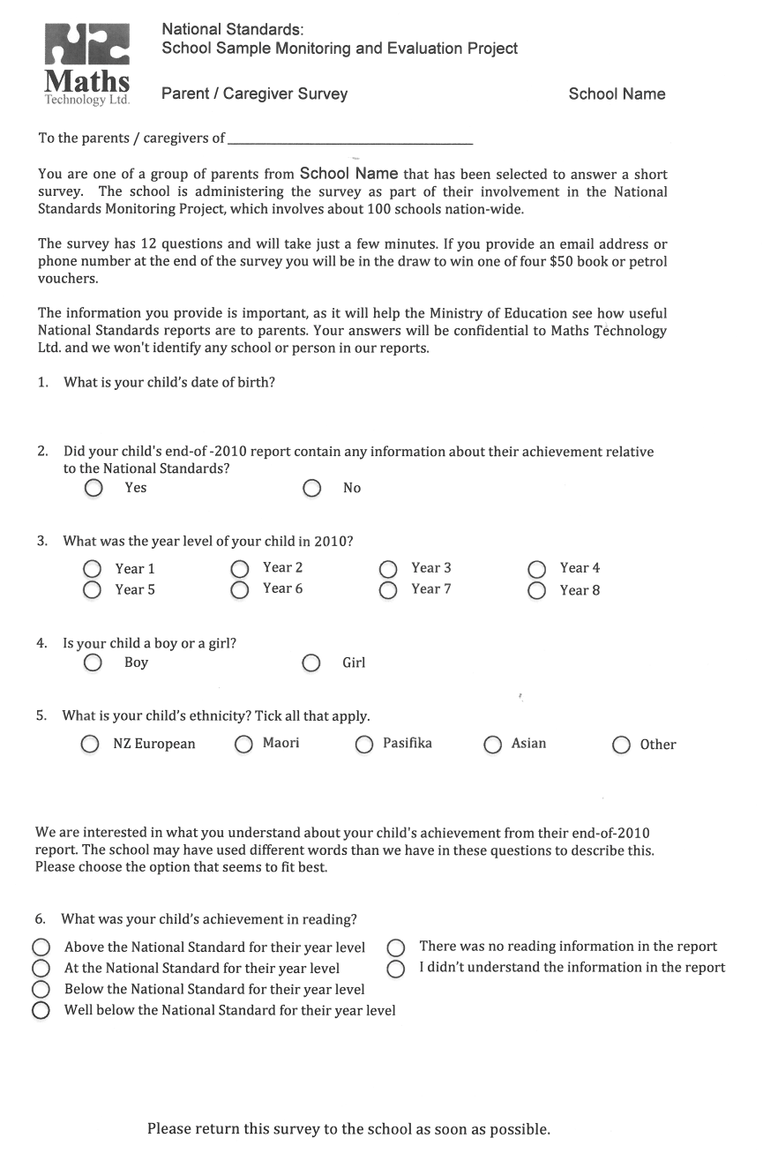
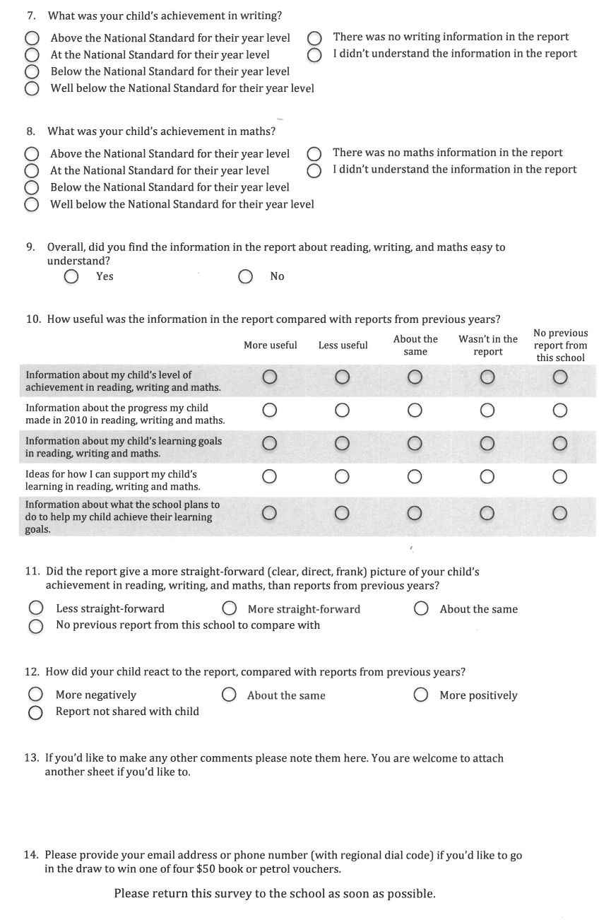

For further details see National Standards: School Sample Monitoring and Evaluation Project, 2010. March, 2011.
Ibid.
Comparative data obtained from Education Counts website: www.educationcounts.govt.nz/statistics/schooling/july school roll returns/6028.
National Standards: School Sample Monitoring and Evaluation Project, 2010. March, 2011.
National Standards: School Sample Monitoring and Evaluation Project, 2010. March, 2011.
National Standards: School Sample Monitoring and Evaluation Project, 2010. March, 2011.
National Standards: School Sample Monitoring and Evaluation Project, 2010. March, 2011.

